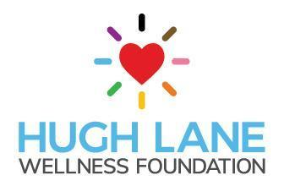
Development Coordinator

The Development Coordinator supports and organizes efforts to expand opportunities and support sustained growth for Hugh Lane Wellness Foundation. This role will be responsible for assisting in application processes, researching emerging opportunities and facilitating models that address health equity for the LGBTQ+ and HIV communities. This is a part-time, hourly position working in collaboration with the Executive Director.

Development
- Research and identify emerging opportunities and gaps in services
- Support the creation and design of new or expanded programming
- Analyze data for growth opportunities
- Facilitate presentations for stakeholder groups

Administration
- Provide direct support to expand HLWF program opportunities
- Create written summaries and reports describing programming and services
- Support and facilitate program delivery for HLWF
- Participate in community events in support of agency growth
- Identify referrals and support connections to key providers in Western PA
- Support resource delivery and coordination throughout our communities

The Ideal Candidate will:

- Have an understanding of gender, sexuality and health disparities impacting the LGBTQ+ communities.
- Have an understanding of racism at the systemic and individual level and be able to implement anti-racist practices in their work
- Work effectively both individually and as part of a team
- Build relationships across community groups and organizations
- Encourage and motivate LGBTQ+ and HIV community members to engage in needed care or support services
- Provide Act 33/34 and FBI clearances prior to starting* (paid for by HLWF)
- Have ability to work outside of typical 9-5 hours

Candidates should email a letter of interest with any supporting documentation, including: resume, previous employment, lived, volunteer or educational experiences to:
sarah@hughlane.org

The Hugh Lane Wellness Foundation is an Equal Opportunity Employer and is committed to recruiting, hiring, supporting and promoting a diverse workforce. We believe that difference in the intersections of identities will lead to a stronger, more innovative team, producing effective results for the communities we serve. We strongly encourage individuals with diverse backgrounds to apply.

*While we are required to procure clearances prior to an offer of employment for all staff, involvement with the justice system that disproportionately impacts Black people, People of Color and LGBTQ+ communities is not an automatic reason for disqualification. There are two instances of disqualification: a person who is registered or required to be registered on a sex offender registry or a person who has been convicted of murder.

